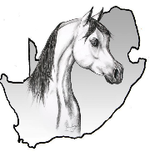
ARAB HORSE SOCIETY OF SA

LEVIES
For 2024
ARAB/PART BRED/ANGLO/PINTABIAN

Compulsary section **Please confirm your details below

*Name of breeder
*Stud name

*NB* E-Mail:

*Cell: Cell 2:

* Address
*Society Acc No: *Member no.:
__________________________________________________________________________________________
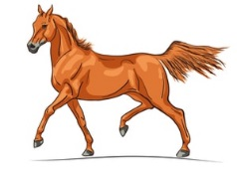
BANKING DETAILS
Arab Horse Society SA
Standardbank
Account number: 041 216 776
Branch code: 055534
Reference: Your SOCIETY DEBITOR (ACC) NR
Proof of Payment: arab@stemma.co.za

__________________________________________________________________________________________

UPDATED HERDLIST MUST BE SEND BACK TOGETHER WITH THIS FORM
RETURN DATE: 29 Fenruary 2024
Number of horses will be invoiced as on 29 February 2024

THIS FORM MUST PLEASE ACCOMPANY YOUR PAYMENT
COMPLETE ALL FIELDS ON THIS FORM

Email: arab@stemma.co.za
Cel: 079 088 4141
Tel: 051 4100 946
Adress: PO Box 506, Bloemfontein 9300

Follow us on Social Media

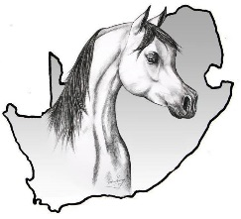
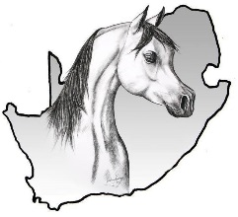
ARAB HORSE SOCIETY OF SA

LEVIES For 2024

Dear Breeder,
Please complete the beneath table as the number of horses will be invoiced.
You’re updated herdlist must be send back together this form.

Catogory | Cost | Total Animals | Total Amount
Pure Bred Arabs
Mares | R75.00 |  | R
Colts 3 years & younger | R75.00 |  | R
Stallions (3 years & older) | R142.00 |  | R
Geldings | R75.00 |  | R
Part Breds
Part Bred & A Mares | R75.00 |  | R
Part Bred Stallions under 3 years | R75.00 |  | R
Part Bred Stallions older that 3 years | R142.00 |  | R
Part Bred Geldings | R75.00 |  | R
Anglo Arabs
Part Bred & A Mares | R75.00 |  | R
Part Bred Stallions under 3 years | R75.00 |  | R
Part Bred Stallions older that 3 years | R142.00 |  | R
Part Bred Geldings | R75.00 |  | R
Membership Fee 2024 |  |  | R 1 322-00
TOTAL AMOUNT DUE |  |  | R
____________________________________________________________________________________________
BANKING DETAILS
Arab Horse Society SA
Standardbank
Account number: 041 216 776
Branch code: 055534
Reference: Your SOCIETY DEBITOR (ACC) NR
Proof of Payment: arab@stemma.co.za
___________________________________________________________________________________________

